Early Agriculture Name______________________
Essential Question: How and where did agriculture begin? What did it look like?

- Agriculture first developed during the ___________________ period, or New Stone Age, an era that lasted from about __________________ until about 5000 BCE. Agriculture developed independently in different areas of the world at different times. The first evidence of agriculture has been found in the ___________ _____________. It is believed that people in this region started farming around 8000 BCE.
- The area where agriculture started is known as the ____________ ______________. People here started to __________________ plant and harvest certain crops such as wheat and barley. Domestication was important to the development of early agricultural societies. Early humans would plant only the _________________ types of grains. As people found the types of crops that grew well, they would plant _______________ of those. This led to more and more _________________ efforts to grow more food.
- Early humans started using ______________ to make their tools during this time. The ___________ was developed as a way to break up soil while the _______________ was developed to cut crops while harvesting.
- Domestication allowed people to _______________ animals instead of hunting them. This involved _______________ breeding: choosing animals with favorable traits. These traits were passed on to make animals that were stronger, produced more meat or milk, or were ______________. The first animals to be __________________ for agriculture were goats and sheep. Their breeding was especially useful in dry climates.

Agriculture = growing food
Neolithic period = The time when agriculture began
Stone Age = The time when all humans were hunter gatherers
Agriculture = growing food, raising animals
Independently = by itself, without help
Evidence = proof
region = an area, a place
BCE = Before Common Era / before Christ lived.
Fertile Crescent. = an area in the middle east , Iraq
Deliberately = on purpose / planned
Crops = plants grown for food
Barley = a type of grain
Domestication = taming animals, breeding animals
development = to change, to grow, to advance
societies = communities or groups of people
Grains = plants we eat with seeds
attempts = to try something
sickle = a curved blade used to harvest
selective breeding = reproduce to get certain type of plant/ animal

traits = behaviors, qualities, types
Especially = mainly
Traditional = old fashioned, the old way of doing something

Y
Describe the changes that lead to the development of Agriculture in the Fertile Crescent:

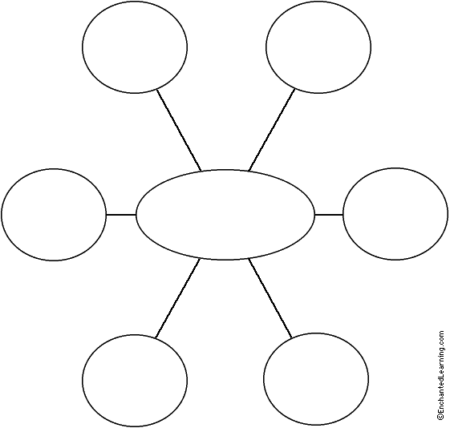
The beginning of Agriculture in the Fertile Crescent (modern day Iraq)
Name________________________
Write a paragraph!!!!! Where did agriculture begin and how was agriculture a new way to produce food? Use complete sentences. Give 3 examples or details. Assume the reader is not familiar with the topic. Write at least 5 sentences.
Sentence 1: Introduce your topic. What are you going to be writing about? __________________________________________ ____________________________________________________________________________________________________________________________________________________________________________________________________
Sentence 2: Define ideas or give your opinion. _______________________________________________________________ ______________________________________________________________________________________________________________________________________________________________________________________________________________________________________________________________________________________________________
Sentence 3: Give an example or a detail about your topic and explain why it is important (you might need 2 sentences) ___________ ______________________________________________________________________________________________________________________________________________________________________________________________________________________________________________________________________________________________________
__________________________________________________________________________________________________
Sentence 4: Give another example or detail about your topic and explain why it is important (you might need 2 sentences)_______
____________________________________________________________________________________________________________________________________________________________________________________________________ ______________________________________________________________________________________________________________________________________________________________________________________________________________________________________________________________________________________________________
Sentence 5: Conclude your paragraph _____________________________________________________________________ ____________________________________________________________________________________________________________________________________________________________________________________________________________________________________________________________________________________________________________________________________________________________________________________________________________

