Early Civilizations Name_________________________________________

Essential Question: Ancient civilization: where did it start and how did it change how people live?

- Early civilizations developed along big _________________. Civilizations tend to be more _________________ in their organization than other types of societies. For example, civilizations usually have organized, _________________ governments and a definite social _________________. Other types of societies, like pastoral nomads or small farming _________________, are more likely to be a loosely organized tribe, based on following a ______________ or strong leader.

- The development of civilizations tended to change the roles of _________________ in society. In earlier societies, like groups of _________________ hunter-gatherers, men and women were more _________________. Once civilizations developed, women began to take on what are considered more _________________ roles. In the earliest civilizations, _________________ became more important as society developed a more complex social ___________________. For example, in Ancient _________________, growing trade allowed more social classes to develop. At the top of the classes were the _________________ and priests. The next level of social class included wealthy _________________ and people with large land holdings. The majority of the population, however, were _________________ (skilled craftspeople), farmers, and laborers. _____________ were at the very bottom of the social hierarchy.

- The _________________ were one of the world's first civilizations and most historians believe that they created the world’s first _________________ system. This system was called _________________, and was made up of pictographs (picture symbols) written on ______________ tablets. The ancient _________________ also had a system of writing that used pictures, called ___________________ but the cuneiform of Ancient Sumer is thought to be _________________. Another development attributed to Ancient Sumer was a number system based on the number __________, also known as a sexagesimal numeral system. This system was very influential and still has many uses even in _________________ world. Because of the sexagesimal system developed by the ancient Sumerians, we still divide a _________________ into 60 seconds and an hour into ___________ minutes.

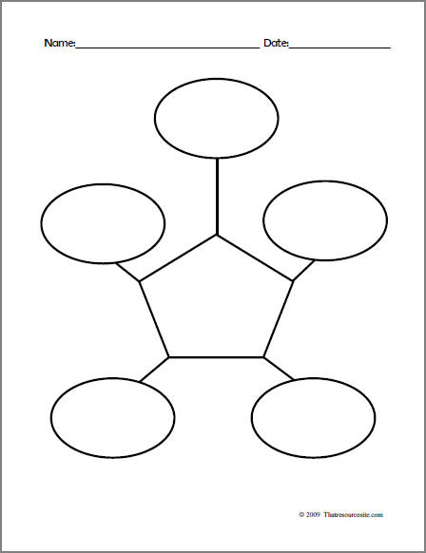
Name_________________________________________
Write a paragraph!!!!! How did civilizations like Ancient Sumer change how people lived? Use complete sentences. Give 3 examples or details. Assume the reader is not familiar with the topic. Write at least 5 sentences.
Sentence 1: Introduce your topic. What are you going to be writing about? ______________________________________________ ______________________________________________________________________________________________________________________________________________________________________________________________________________
Sentence 2: Define ideas or give your opinion. ____________________________________________________________________ _____________________________________________________________________________________________________________________________________________________________________________________________________________________________________________________________________________________________________________________
Sentence 3: Give an example or a detail about your topic and explain why it is important (you might need 2 sentences) _________________ _____________________________________________________________________________________________________________________________________________________________________________________________________________________________________________________________________________________________________________________
_______________________________________________________________________________________________________
Sentence 4: Give another example or detail about your topic and explain why it is important (you might need 2 sentences)______________
______________________________________________________________________________________________________________________________________________________________________________________________________________ _____________________________________________________________________________________________________________________________________________________________________________________________________________________________________________________________________________________________________________________
Sentence 5: Give another example or detail about your topic and explain why it is important (you might need 2 sentences)____________ ______________________________________________________________________________________________________________________________________________________________________________________________________________ ________________________________________________________________________________________________________ Sentence 6: Conclude your paragraph _________________________________________________________________________ ______________________________________________________________________________________________________________________________________________________________________________________________________________

