Intro to World History Name_______________________

Essential Question: How do we know what happened in the past? Hip Hop case study

What is this?
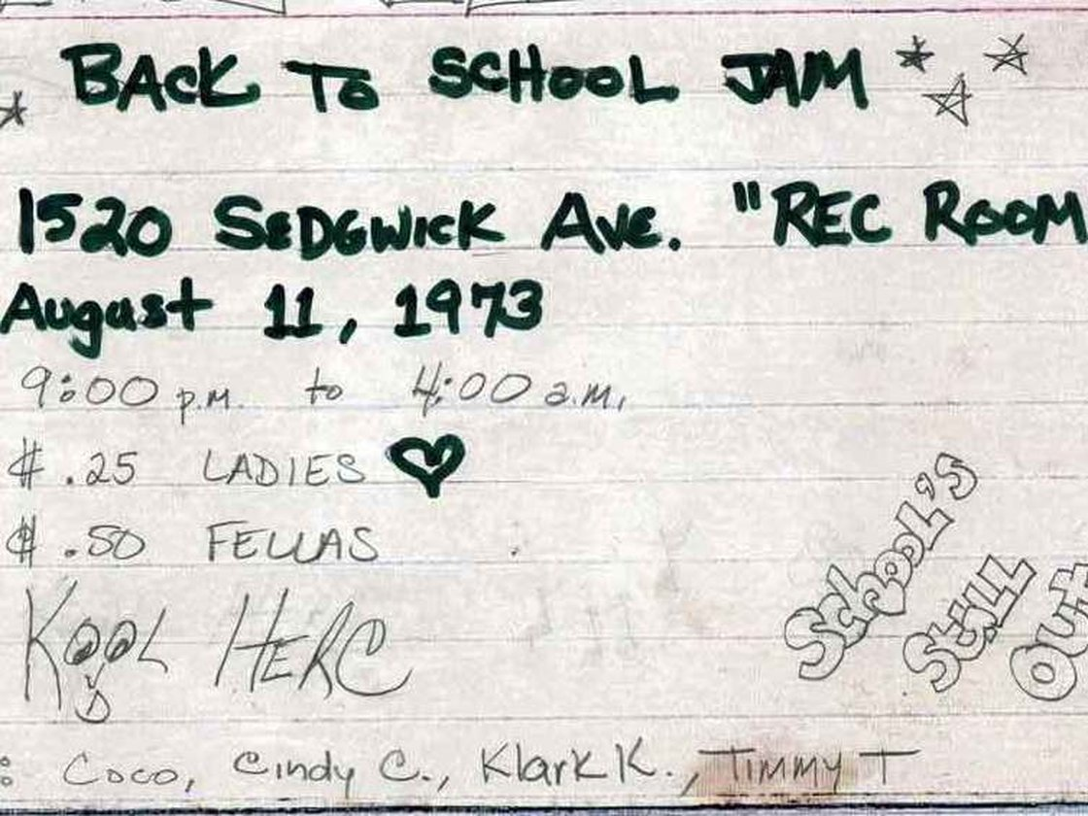

- Describe the primary source – What is it?

- Why is it a primary source?

- How old is the source? When was it made or recorded (guess if not sure)?

- How is it unique or different compared to our time?

- How is it the same compared to our time?

- What is the intent or purpose of the primary source?

- Whose point of view does it represent?

- Is it authentic or accurate?

- How does it connect to us (why is it important)?

