Global Issues Social Action Project Name_____________________
Essential Question for the class: Based on an analysis of world history, can humans create a just, sustainable, complex society? Can we create a better future for ourselves by using our knowledge of the past?

In this project you will select an important modern problem and offer a possible solution. In order to do this you will analyze several historical examples of past societies that dealt with the same or similar problems.

Your project will have a visual component, a written component and will present your project in public.

- Visual Component: It can be a Power Point, A Prezi or a IMovie

- Written Component: a written essay where you identify a modern problem and offer a solution which is backed by historical examples

- Presentation: you will share your project in public

Project Requirements
Select a topic
- Needs to be important to you
- Needs to have existed in some form in the past
Introduce your topic
- Explain issue and why it is important
- Offer a solution based historical examples

Historical background of issue (Choose Three)
- Ancient times (40,000 B.C.E. to 500 C.E.)
- Post Classical Era (500 C.E. to 1500 C.E.)
- Early Modern (1500 C.E. to 1800 C.E.)
- Modern (1800 to Today)
Issue in different locations (Choose at least two)

- Europe
- Asia
- Africa

- South America
- North America
- Middle East

Possible Analysis Questions
- How is the issue relevant today?
- What are similar historical examples compared to today?
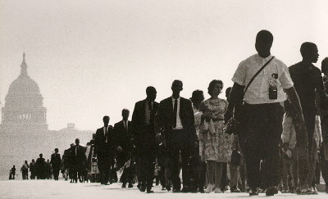
- How is has this issue changed or stayed the same through different times and places?
- What do past experiences tell us about today’s issues?
- What can be done in the future?
- What is your personal opinion? Might others disagree?
- Additional questions that might arise
- (You have to do this one: Choose your own question)
Offer a possible solution to the issue
- Use relevant historical examples when explaining your solution
Some Topic Suggestions (Feel free to change or think of your own – must be approved by your instructor):
- Environment/Technology

Climate change
Overpopulation
Pollution
Resource shortages
Habitat destruction/Extinction
Recycling
Information technology/computers
Transportation
Trade/Globalization
Health/epidemics
Agriculture
Industrialization
War/Military technology
Evaluate civilization

- Resources/Poverty

Poverty
Homelessness
Unemployment
Hunger
Division of wealth
Taxes
Access to health care
Access to education
Access to healthy food
Pollution among poor
Health problems of the poor
National debt
Personal debt
Property rights
Copyrights

- Conflict

War
Weapons of mass destruction
National/racial/ethnic/religious
Street violence
Women in the military
Gang violence
Gun violence
School violence
Sexual assault

- Culture Unit

Fashion and class
School uniforms
Negative images of women
Negative images of ethnic groups
Immigration issues
LGBT issues
Music and society
Violent entertainment
Urban myths
Conspiracy theories
News media
Cinema and society
Racism
Sexism
Youth empowerment
Preserving languages
Preserving cultures

- Power and Authority Unit

Civil Rights
Voting
Censorship/freedom of Speech
Freedom of religion
Gun issues
Police issues
Youth rights
Federalism (federal vs local government)
High incarceration rates in the US
Prison issues
Computers and privacy
Democracy
Dictatorships
Political prisoners
Drug legalization
Youth curfew

